HOME Page

1. LOGO: href to ‘./’
2. 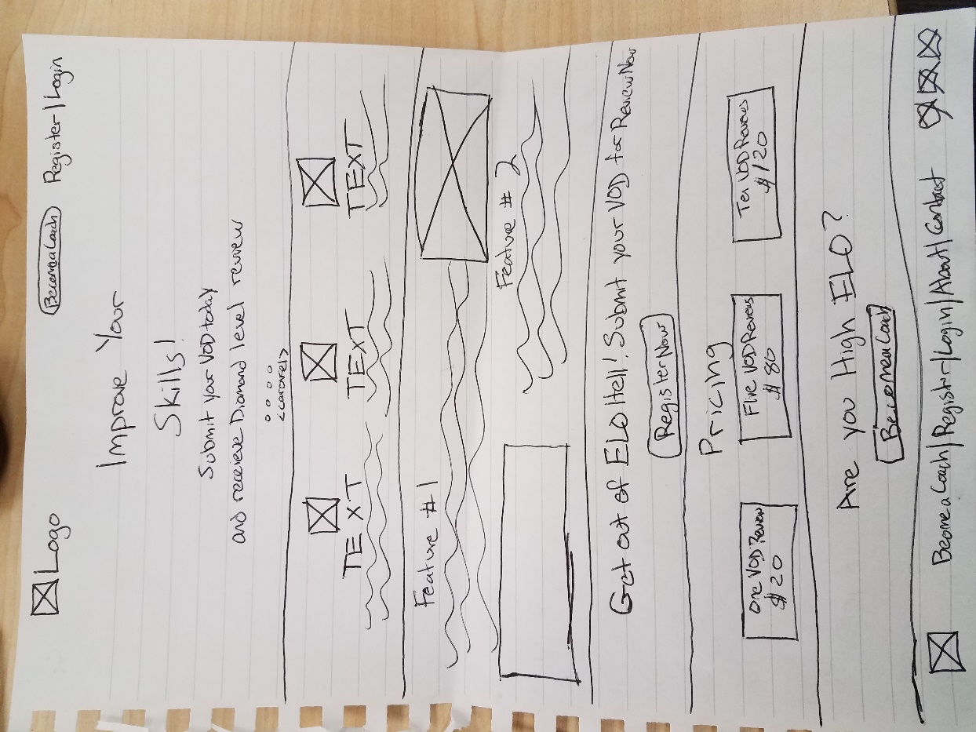Become a Coach: button to Coach info and registration
3. Register: Modal to register
4. Login: Modal to login
5. Jumbotron: background image or GIF
6. Register Now: button to register
7. Become a Coach: button to Coach registration
8. Footer Links

USER Page: <VOD Request Form NAVPILL Selected>

1. 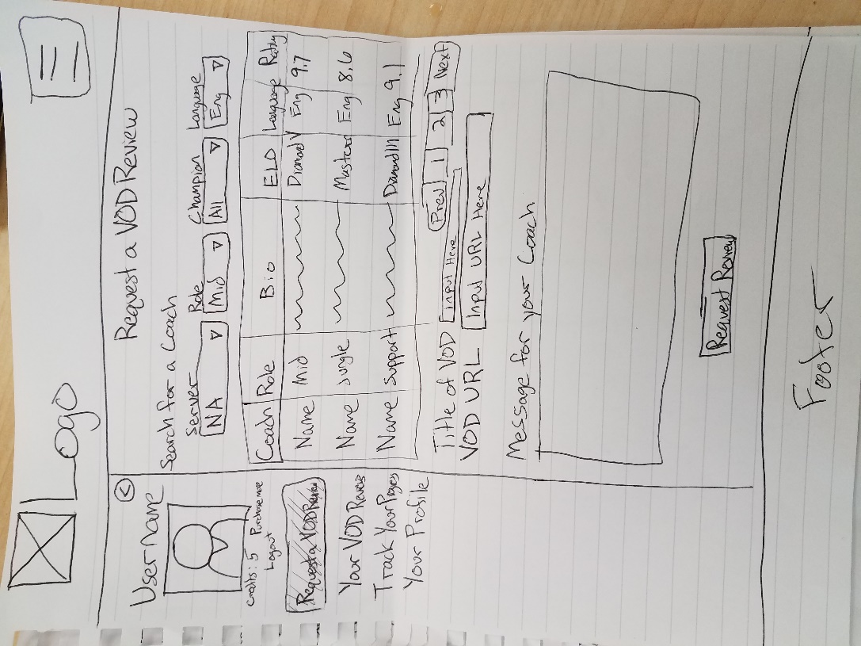Navbar Menu Button
2. Side Bar Collapse Button
3. NavPills
4. Coach Filter Dropdown lists
5. Coach Table navigation buttons
6. Request Review Button
7. Footer Links

User Page: <Your VOD Reviews NAVPILL Selected>

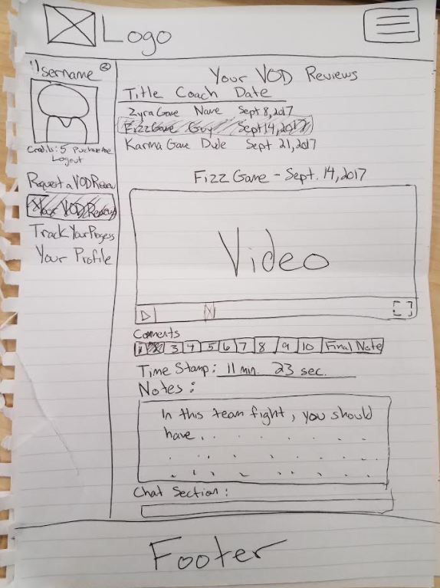

1. Navbar Menu Button
2. Side Bar Collapse Button
3. NavPills
4. VOD Select Buttons: will display Video when clicked
5. Video Player: embeded video player
6. Comments button
7. TimeStamp: somehow link up to Video time stamp
8. Notes: Get Request
9. Chat Section: Get Request

User Page: <Track your progress NAVPILL Selected>

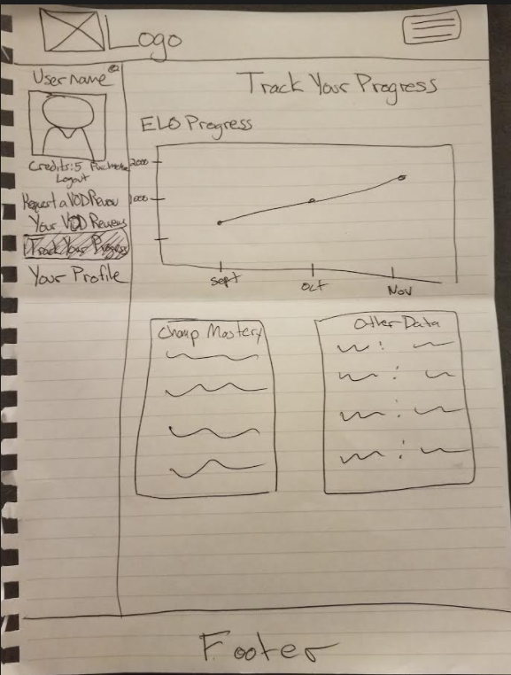

1. Navbar Menu Button
2. Side Bar Collapse Button
3. NavPills
4. GRAPHS and TABLE: API request from Riot Game API
5. Footer Links

Coach Page: <VOD Review Requests Inbox NAVPILL Selected>

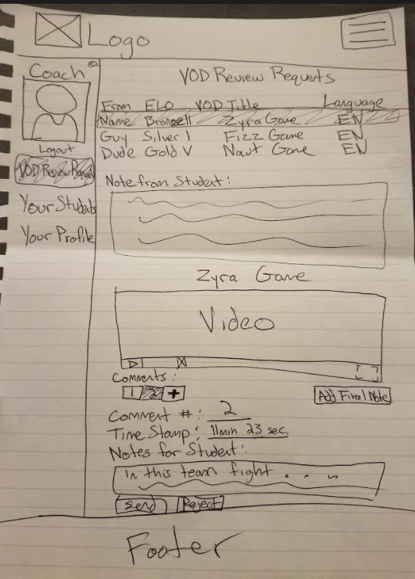

1. Navbar Menu Button
2. Side Bar Collapse Button
3. NavPills
4. VOD Select Buttons: will display VOD Review request when clicked
5. Notes from Student: GET request
6. Video Player: embeded video of GET request
7. Add Comment Button: will add a comment when clicked
   1. Will also automatically record time-stamp for point of video
8. Notes for Student: Input Box for comments
9. Send/Reject Buttons: Send will POST; Reject will open up reject Modal for reason why rejecting???
10. Footer Links

Coach Page: <Your Students NAVPILL Selected>

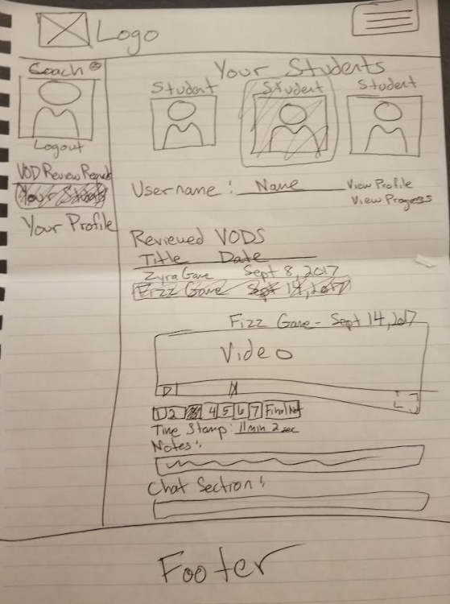

1. Navbar Menu Button
2. Side Bar Collapse Button
3. NavPills
4. Student Profile Pictures: clicking one will open up body content of past VOD Reviews
5. Username: populates with username once student is selected; also has view profile and view progress buttons
6. Reviewed VODS table: GET request showing all of the VOD reviews you have sent your student; when one is chosen, will display VOD review below
7. Video Player: embeded video player
8. Comment Buttons: navpill buttons that display different comments
9. Notes: notes you gave your student; GET request
10. Chat Section: chat section with your student
11. Footer Links

Branches:

1. Master
   1. Deployment
      1. HomePage -----------------Pat
      2. UserPage
         1. UserVODS -------James
         2. TrackProgress---Brian
         3. UserProfile-------Brian
      3. CoachPage
         1. CoachVODS ------James
         2. CoachProfile -----Brian
      4. Backend ----------------------Joe